`



**

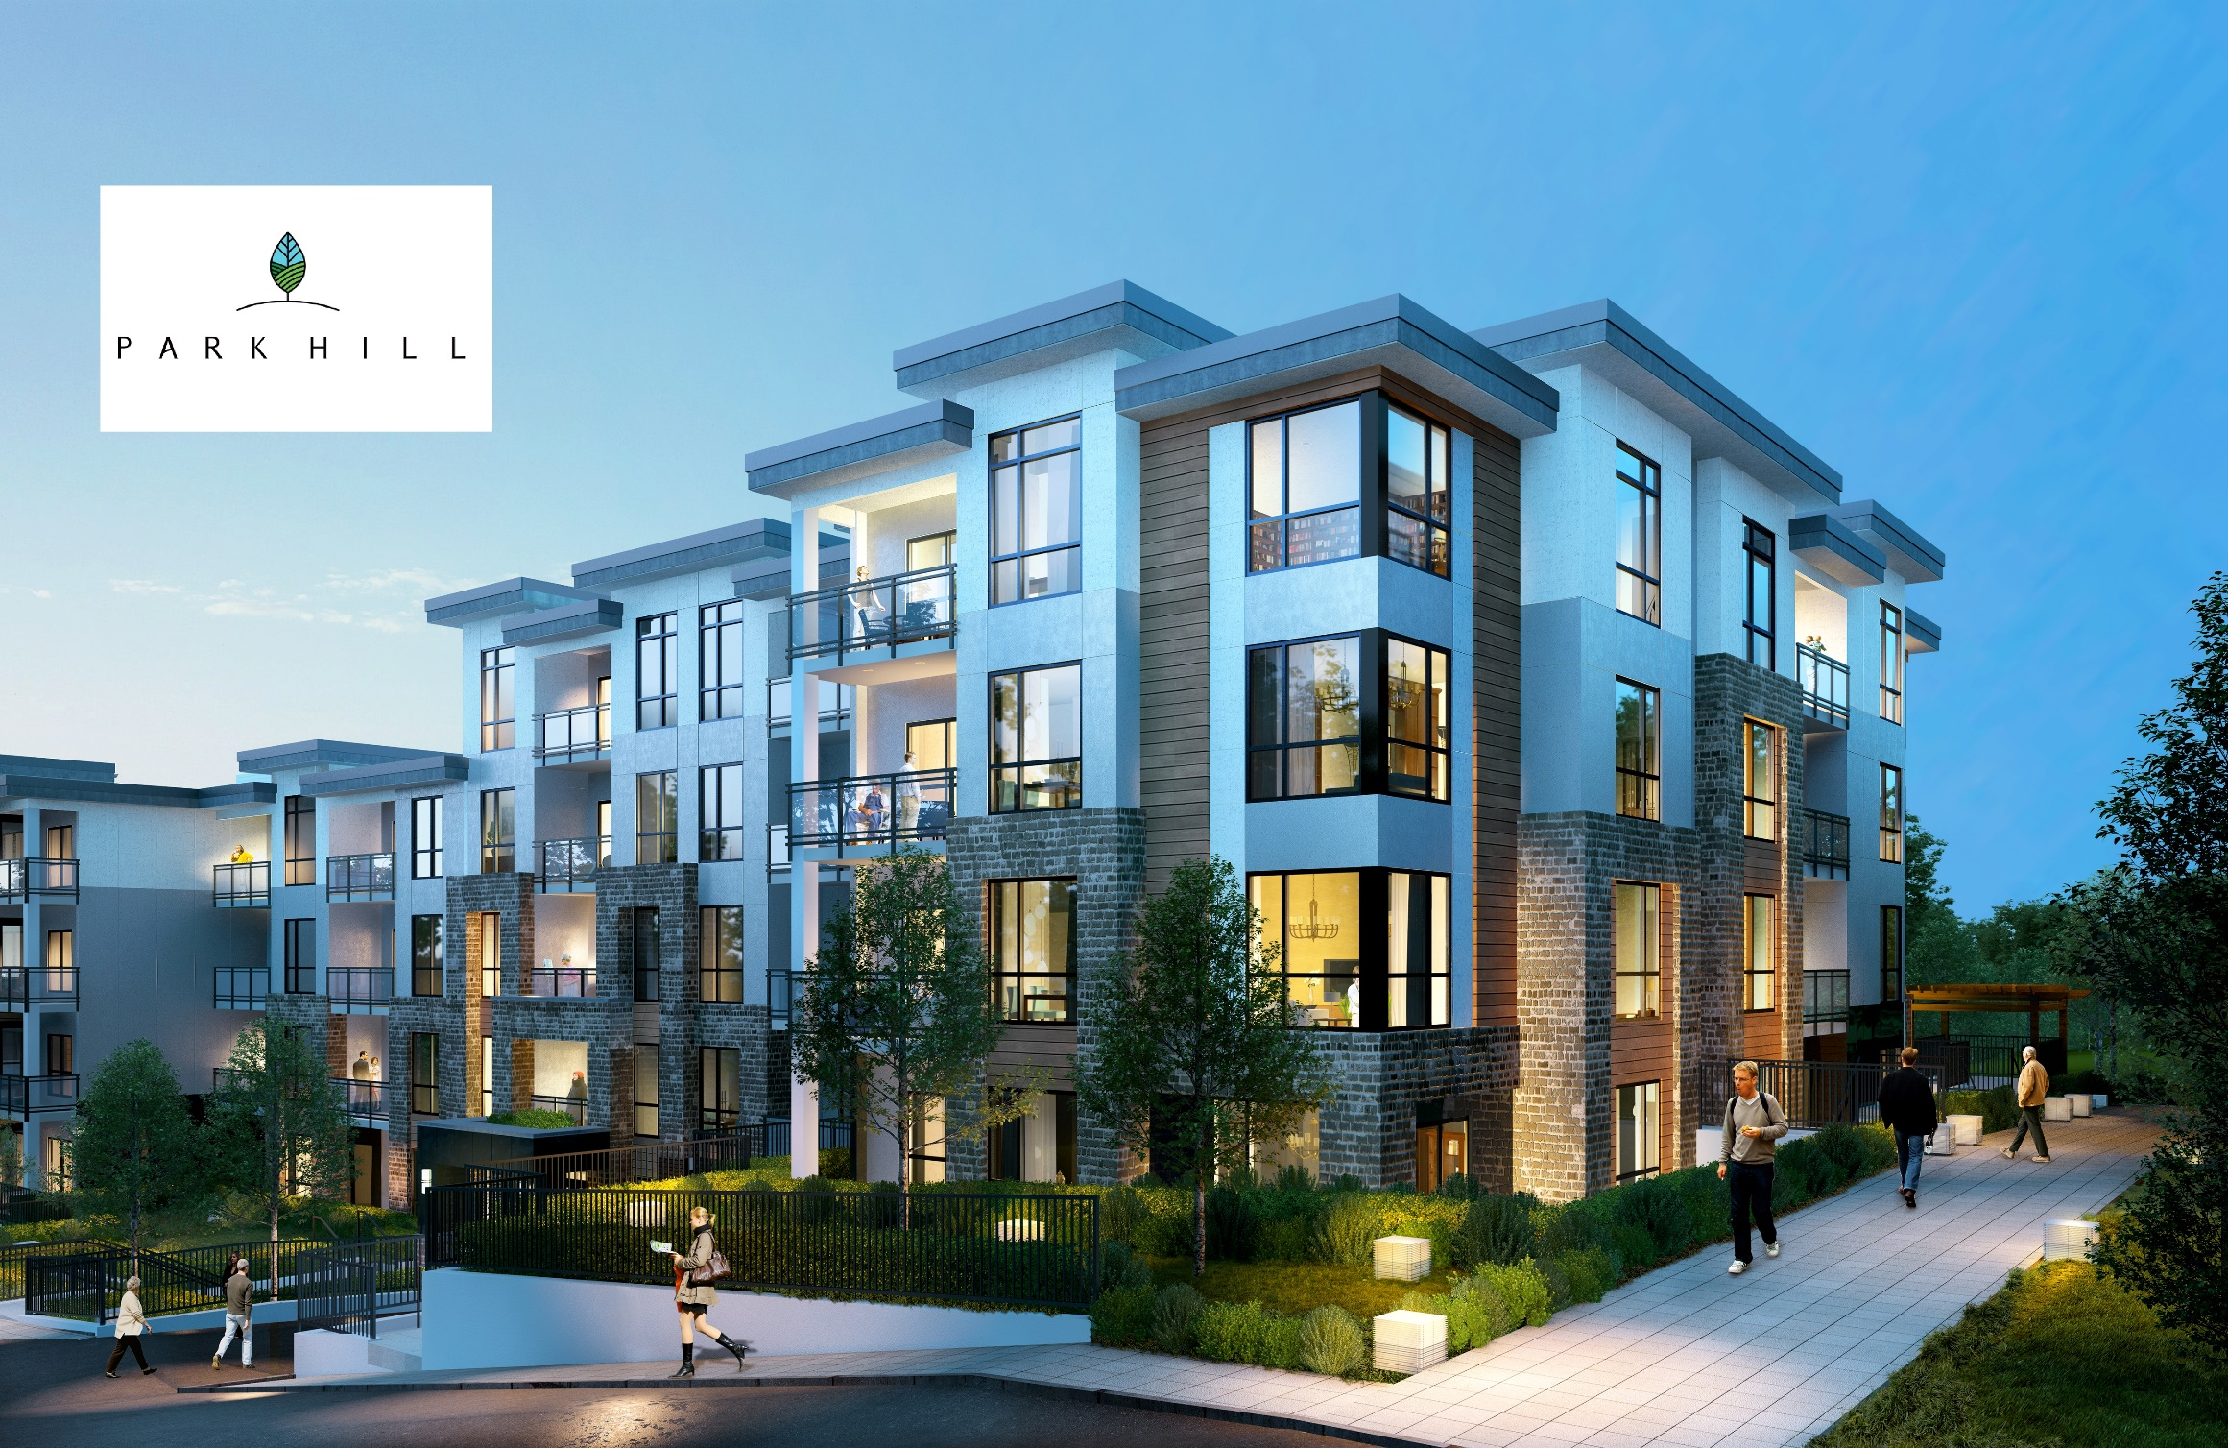Renderings are an artist interpretation only and subject to change without notice.

**CONDOS** Park Hill’s modern condos feature thoughtfully designed floorplans offering spacious kitchens with Quartz counters, sleek SS appliances, elegant nine-foot ceilings, modern vinyl resistant floors in the main area and plush carpets in the bedroom. Natural light fills these homes through bright oversized windows. Backing onto a lush forest area giving you Room to Breathe.

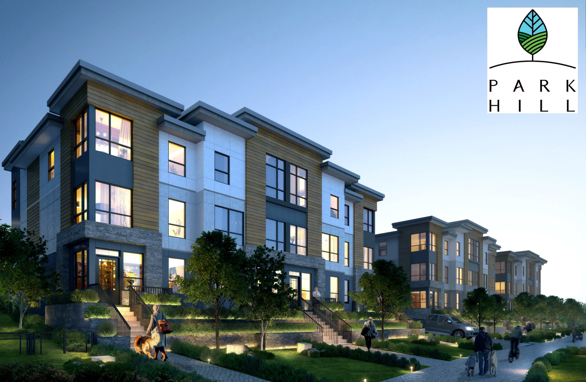  
Renderings are an artist interpretation only and subject to change without notice.

**TOWNHOMES** Park Hill’s Urban Townhomes offer stunning walk up front entries with spaciously designed floorplans focused on natural light and luxurious finishings. Stunning kitchens with a large island and built-in pantry, sleek Samsung SS appliances, elegant 9ft ceilings and modern vinyl resistant floors on the main with large bright windows to flood in natural sunlight. Upstairs plush carpet greets you with ceilings vaulted up to fourteen-feet.

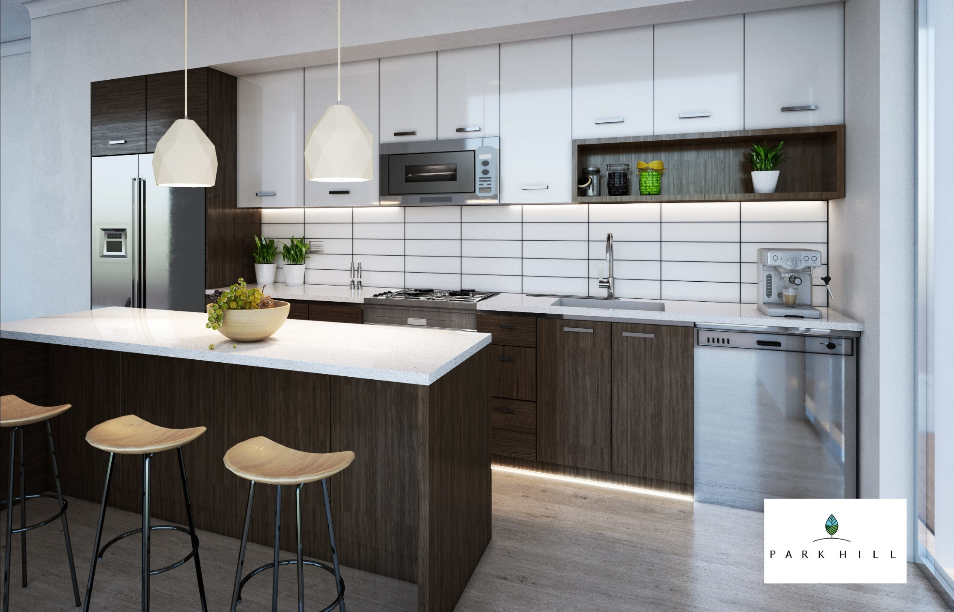Renderings are an artist interpretation only and subject to change without notice.

**INTERIOR** Stunning Northwest Pacific Northwest Inspired kitchens were carefully crafted with a chef in mind. Perfect for entertaining with large Islands and thoughtfully designed storage space including a full height pantry. Modern flat panel cabinets in white and rich dark oak accented with brushed nickel hardware and soft close hinges. Quartz counters, subway tiled backsplash and a SS Blanco Horizon under-mount sink, and a Samsung SS appliance package finish off these stunning kitchens.

|  |  |  |  |  |  |  |  |  |  |  |  |  |  |  |  |  |  |  |  |  |  |  |  |  |  |  |  |  |  |  |  |  |  |
| --- | --- | --- | --- | --- | --- | --- | --- | --- | --- | --- | --- | --- | --- | --- | --- | --- | --- | --- | --- | --- | --- | --- | --- | --- | --- | --- | --- | --- | --- | --- | --- | --- | --- |
|  | **TOWNHOMES**   |  |  |  |  | | --- | --- | --- | --- | | **Plan** | **Type** | **Size** | **Price Range** | | A1 | 2 bed + flex, 3 bath | 1520 sq. ft. | $657k - $664k | | A | 2 bed + flex, 3 bath | 1518 sq. ft. | $652,800 | | B | 3 bed + flex, 3 bath | 1804 sq. ft. | $767,700 | | C | 2 bed + flex, 3 bath | 1712 sq. ft. | $712k - $738k |   **CONDOS**   |  |  |  |  | | --- | --- | --- | --- | | **Plan** | **Type** | **Size** | **Price Range** | | B | 2 bed, 2 bath | 1216 sq. ft. | $597k - $627k | | E, E2 | 2 bed, 2 bath | 931 sq. ft. | $450k - $490k |   Additional floorplans available upon request.  All prices are subject to GST and subject to change without notice E.&O.E.  Nov 20, 2017 |

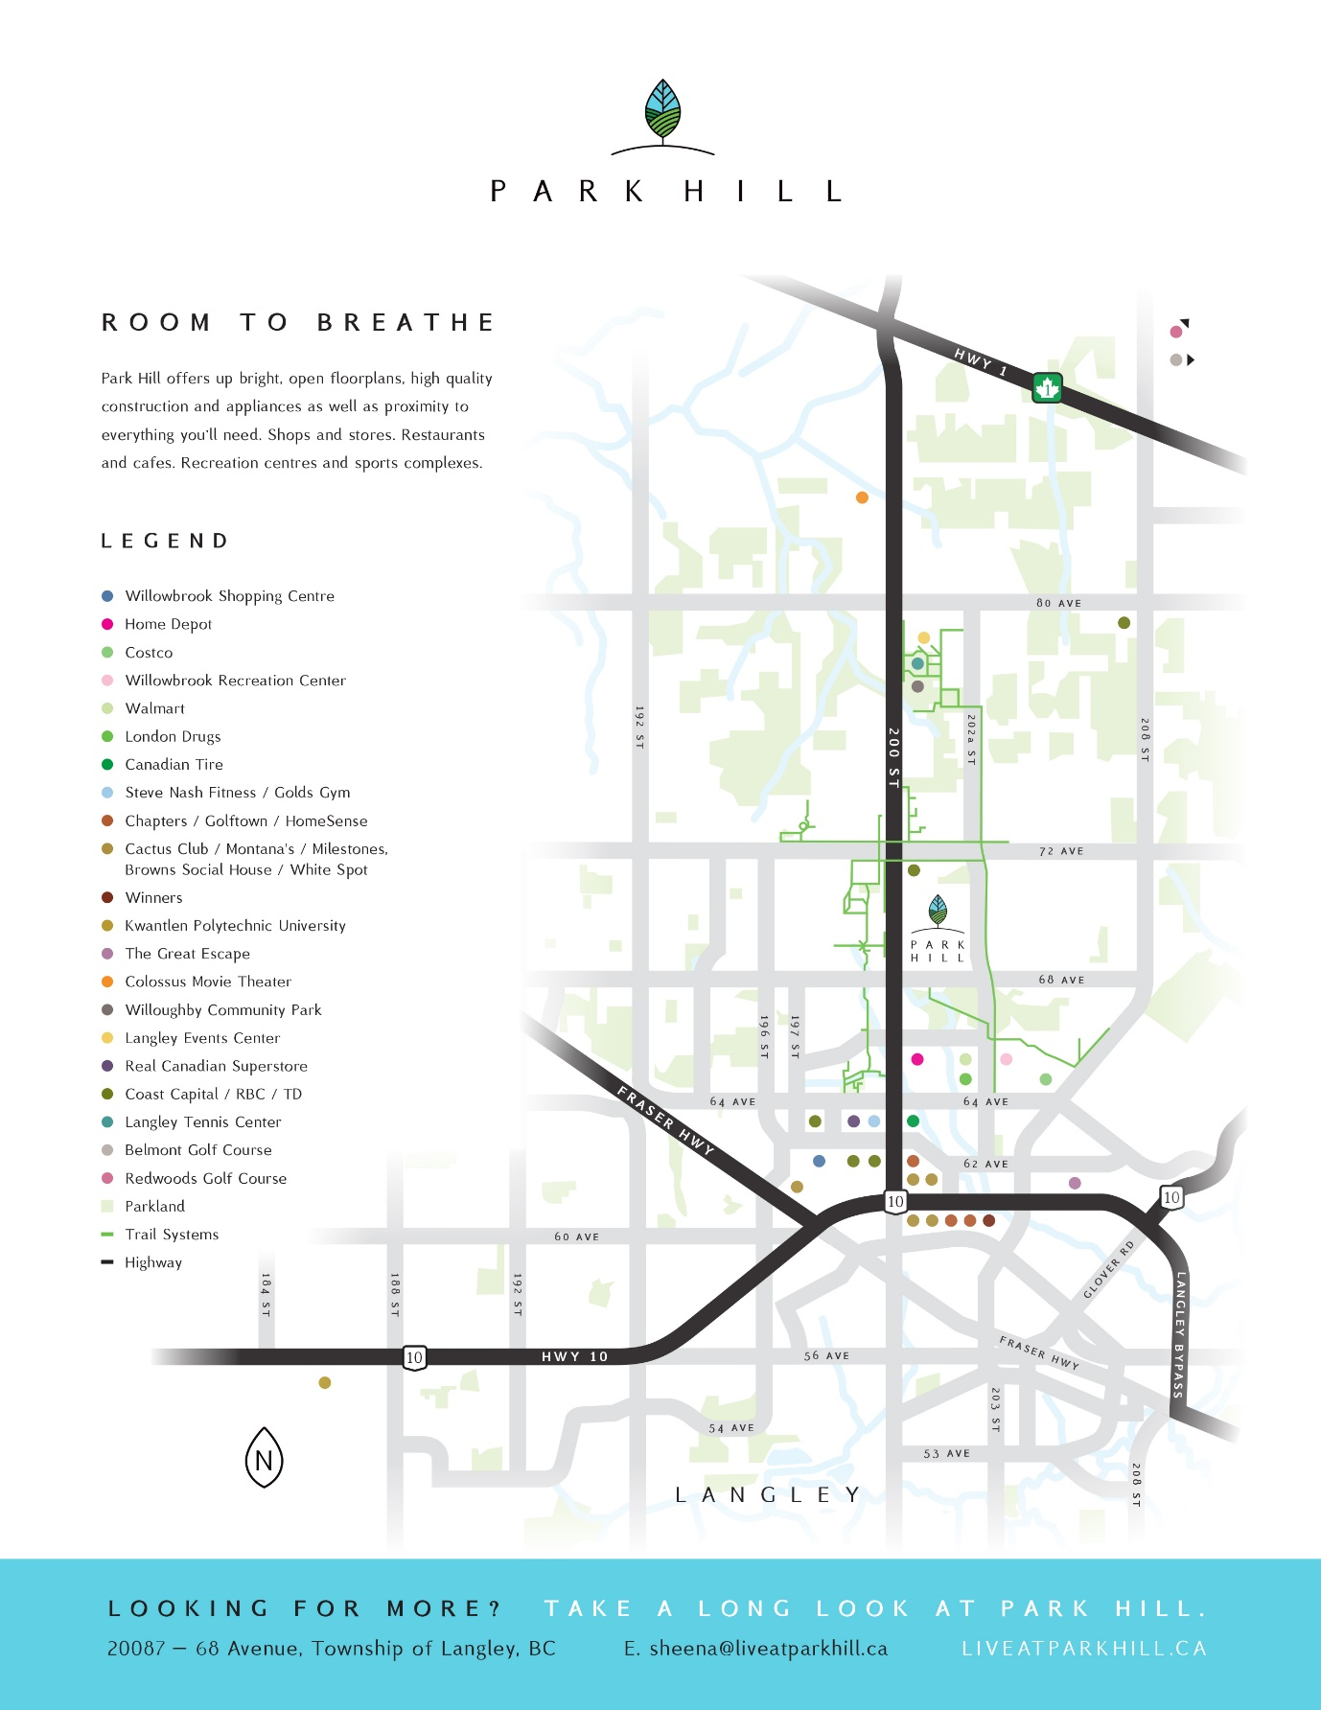

|  |  |
| --- | --- |
|  | **FOREWEST GROUP**  Homes built by Forewest Group are distinctive and unique. As a local builder, we have over 95 years of combined experience. The advantage of this lengthy history in the industry has taught us never to compromise on our commitment to superior quality construction.  We’ve learned to partner with only BC’s best architects and tradesmen, an alliance that has brought rich quality and steadfast reliability to our diverse portfolio of projects.  Whether it’s retail, industrial or residential developments, the Forewest signature has become synonymous with excellence in every aspect of construction. You’ll see it in our homes at Park Hill, a higher echelon of quality that’s etched into the architecture, design and final finishings of these residences.  Together with Travellers Canada Warranty Program, Forewest Group (Park Hill) provides a 2-5-10 Warranty in accordance with the Homeowner Protection Act of British Columbia. This comprehensive third-party warranty includes a two-year materials and labour warranty, a five-year building envelope warranty and a ten-year structural warranty.  This meaning is clear: Your Park Hill home is an invaluable, long term investment that promises years of peace-of-mind and a lifetime of satisfaction. |



*Live At Park Hill*

MORE INDOOR SPACE.

MORE OUDOOR SPACE.

MORE LIVING SPACE.

COUNTRY LIVING AT YOUR DOORSTEP.

TAKE A LONG LOOK AT PARK HILL.